[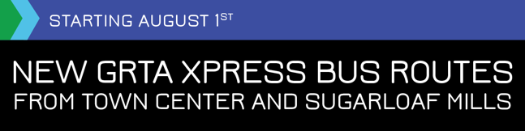](http://bit.ly/PerimeterXpress)

All Perimeter commuters from **Cobb** and **Gwinnett** now have a new way to get to work on an Xpress bus!

**Starting August 1**, two new GRTA Xpress buses with **direct routes** and **scheduled departures** are headed to Perimeter.

These comfy coach-style buses are equipped with charging ports and free on-board Wi-Fi so you can use your time more  productively. Get ready to sit back, relax, and let someone else do the driving.

* **Route 482** from [Town Center/Big Shanty](http://perimeterconnects.com/xpress/) to Perimeter Center
* **Route 417** from [Sugarloaf Mills](http://perimeterconnects.com/xpress/) to Perimeter Center

**Great news:**The first **two weeks are free!**You can hop on with no tickets or Breezecard. No sign-ups, just show up and ride!

[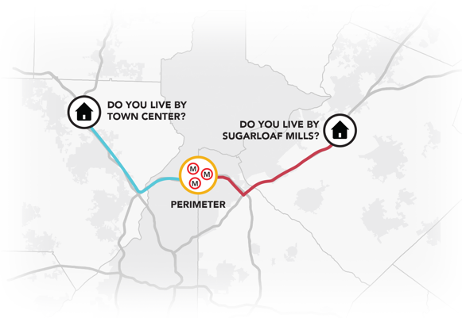](http://perimeterconnects.com/xpress/)

**Get all the details at:**

[**PerimeterConnects.com/Xpress**](http://perimeterconnects.com/xpress/)

[](http://bit.ly/PCxpress)