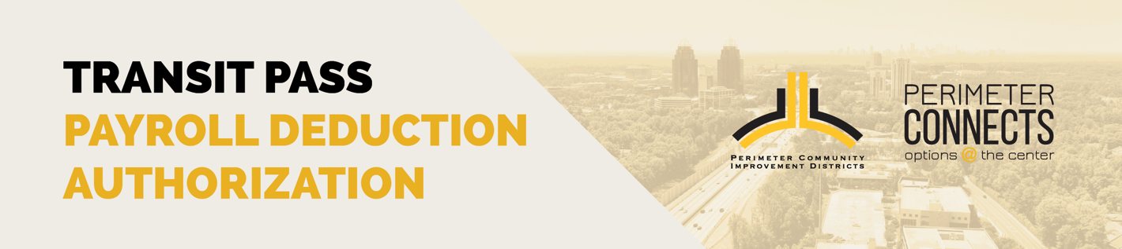

I hereby authorize _____________________ to deduct $_______ from the first paycheck of each month on a pre-tax basis to be used for the purchase of a Transit Pass. I understand that once the deduction is
started it will be re-occurring until the I send this form via email to ______________________________
and select the statement below to stop the deduction.

I understand that deductions will be made on the first pay period of the month and will pay for the entire month’s MARTA Breeze benefits. I understand that I must enroll or cancel by the 11th of the month in order for benefits to load or not load on my card for the following month . MARTA Breeze cards are not eligible for any refunds.

I will be using the benefit exclusively for my regular daily direct commute from home to work and return. I will not give, barter, exchange, convey or otherwise transfer this benefit to any other person.

I understand that if I leave _____________________ , voluntarily or involuntary, before the end of a month in which a payroll deduction has been made for the pass, I will not be asked to return the pass and I will not be refunded any monies. I further understand that if the pass is lost or stolen, a replacement pass will be issued for a fee of $2.00.

I understand and agree that false certification may result in disciplinary action taken by
_____________________ up to and include dismissal from employment .

Example: Submitting this completed form by March 11th would give you the unlimited Marta Transit Pass for the month of April. The pre-tax deduction would be taken on the first payroll in April.

*Please return completed form to [_____________________________, __________________________]

_________________ Deduct the monthly amount for a MARTA Pass
_________________ Cancel the monthly amount for a MARTA Pass
(any cancellation after the 11th of the month, will not be canceled until the following month)

Signed: ___________________________________________________ Date: _________________

Print: ___________________________________________________

